### MAJOR PROJECT

## Twitter Sentiment Analysis

*By RAMANAND R*

Artificial Intelligence Intern

Ineubytes

# Table of Contents

1. Introduction

2. Installation and Setup

* Software and Libraries Used
* Step-by-Step Setup Instructions

3. Dataset Preparation

* Obtaining and Loading the Twitter Dataset
* Handling Missing Values
* Removing Duplicates

4. Text Preprocessing

* Text Preprocessing Techniques
* Code Snippets and Examples

5. Tokenization and Feature Extraction

* Tokenization Method
* Tokenization Process
* Feature Extraction Techniques

6. Naive Bayes Classification

* Implementation of Naive Bayes Classification
* Training Process
* Testing and Validation

1. Model Evaluation

* Metrics for Model Evaluation
* Confusion Matrix
* Code Snippet for Confusion Matrix
* Histogram
* Bar Plot for Top N Most Frequent words

1. Prediction with new data

* Using the Trained Model for Prediction
* User-Friendly Interface

1. Conclusion

* Project Objectives and Achievements
* Importance of Sentiment Analysis in Real-World Applications
* Challenges Faced During the Project

# 1. Introduction

The primary goal of this project is to perform sentiment analysis on Twitter data using natural language processing (NLP) techniques and machine learning. Sentiment analysis, also known as opinion mining, is a field of NLP that involves determining the sentiment or emotional tone expressed in text data, in this case, Twitter reviews. By analyzing the sentiment of tweets, we aim to gain insights into public opinions, track brand sentiments, or monitor user sentiments on various topics.

**Dataset Source and Importance**

The dataset used in this project is sourced from [provide the URL or source where you obtained the dataset]. It is a collection of Twitter reviews, each labeled with its corresponding sentiment, which can be positive, negative, or neutral. The dataset's importance in sentiment analysis lies in its real-world applicability, as Twitter is a platform where users express a wide range of sentiments on diverse topics, making it a valuable resource for sentiment analysis research and applications.

**Document Overview**

This document provides a comprehensive overview of the major internship project, which involves data cleaning, tokenization, and Naive Bayes classification on the Twitter dataset. It outlines the steps taken to prepare, preprocess, and analyze the data, as well as the evaluation of the Naive Bayes classifier's performance. The document also covers the implementation of a user-friendly interface for predicting sentiment in new Twitter reviews using the trained model.

The following sections will detail each step of the project, from dataset preparation to model evaluation, and will include explanations, code snippets, and visualizations to provide a thorough understanding of the entire process. Additionally, the document will conclude with a summary of project objectives and achievements, emphasizing the significance of sentiment analysis in the context of Twitter data.

# 2. Installation and Setup

**Software and Libraries Used**

In this project, we utilized several software tools and libraries to perform data cleaning, tokenization, and Naive Bayes classification on the Twitter dataset. The key components include:

1. *Python*: Python is the primary programming language used for this project due to its versatility in data analysis and machine learning tasks.

2. *scikit-learn*: Scikit-learn is a powerful Python library for machine learning and data mining. We leveraged scikit-learn for implementing the Naive Bayes classifier and performing model evaluation.

3. *NLTK (Natural Language Toolkit)*: NLTK is a Python library specifically designed for natural language processing tasks. We used NLTK for text preprocessing, which includes tasks such as removing stopwords and applying stemming or lemmatization.

**Step-by-Step Setup Instructions**

To set up the development environment for this project, follow these steps:

*Step 1: Install Python*

If Python is not already installed on your system, download and install the latest version of Python from the official Python website (<https://www.python.org/downloads/>).

*Step 2: Install Dependencies*

- Open your command prompt or terminal.

- Install scikit-learn using pip:

pip install scikit-learn

- Install NLTK using pip:

pip install nltk

*Step 3: Download NLTK Data*

- After installing NLTK, download the necessary NLTK data packages by running Python's interactive shell (open the terminal or command prompt and type `python`):

import nltk

nltk.download('stopwords')

*Step 4: Create a Virtual Environment (Optional but Recommended)*

- To keep your project dependencies isolated, consider creating a virtual environment. You can use the `venv` module that comes with Python:

python -m venv myenv

*Step 5: Install Jupyter Notebook (Optional but Recommended)*

- If you plan to use Jupyter Notebook for code development and documentation, install it using pip:

pip install notebook

Step 6: Launch Jupyter Notebook (Optional)

- Navigate to your project directory and run Jupyter Notebook:

jupyter notebook

# 3. Dataset Preparation

Now, we'll detail the steps involved in obtaining, loading, and preparing the Twitter dataset for sentiment analysis. Proper dataset preparation is crucial for accurate and meaningful analysis.

***Obtaining and Loading the Twitter Dataset***

1. *Data Source*: The Twitter dataset used in this project was obtained from <https://www.kaggle.com/datasets/ineubytes/twitter-sentiment-analysis>. This dataset includes Twitter reviews along with their corresponding sentiment labels (positive, negative, or neutral).

1. *Data Format*: The dataset is typically available in a CSV (Comma-Separated Values) format, where each row represents a Twitter review and includes columns for the review text and its associated sentiment label.
2. *Loading the Dataset*: We used Python libraries like pandas to load the dataset into our development environment. Here's a code snippet for loading the dataset:

import pandas as pd

# Load Dataset and added column names

twitter_training = pd.read_csv('twitter_training.csv', delimiter=',', header=None, names=['ID', 'Topic', 'Sentiment', 'Text'])

twitter_validation = pd.read_csv('twitter_validation.csv', delimiter=',', header=None, names=['ID', 'Topic', 'Sentiment', 'Text'])

***Handling Missing Values***

It's common for real-world datasets to contain missing values. Here's how we handled them:

*1. Identification:* We initially identified missing values in the dataset using functions like `isnull()` or `isna()`. This helped us understand the extent of missing data.

*2. Handling Missing Values:* Depending on the dataset, there are several approaches to handling missing values, including removal, imputation, or using advanced techniques. We chose the most appropriate strategy for our dataset. For instance, to remove rows with missing values:

# Remove rows with missing values

twitter_training.dropna(inplace=True)

twitter_validation.dropna(inplace=True)

***Removing Duplicates***

Duplicate records can skew the analysis results. To ensure data consistency:

1. *Identify Duplicates*: We used functions like `duplicated()` to identify duplicate rows in the dataset.

2. *Remove Duplicates*: Duplicate rows were removed to maintain data integrity. Here's how we removed duplicates:

# Remove duplicate rows

twitter_training.dropna(inplace=True)

twitter_validation.dropna(inplace=True)

*Data Consistency*

Ensuring data consistency is crucial for accurate analysis. It involves addressing inconsistencies or noise in the data. Common issues include inconsistent capitalization, special characters, or variations in sentiment labels. Here's how we ensured data consistency:

1. *Text Cleaning*: We applied text cleaning techniques to make text data consistent, such as converting text to lowercase, removing special characters, and eliminating extra spaces.

2. *Sentiment Label Consistency*: We standardized sentiment labels (e.g., 'positive' and 'negative') to ensure uniformity.

By following these steps, we prepared the Twitter dataset for subsequent data Preprocessing, Tokenization, and Sentiment analysis. Proper dataset preparation lays the foundation for accurate and meaningful sentiment analysis results.

# 4. Text Preprocessing

Text preprocessing is a critical step in natural language processing (NLP) that involves cleaning and standardizing text data to make it suitable for analysis. In this section, we'll describe the text preprocessing techniques applied to prepare Twitter reviews for sentiment analysis.

***Text Preprocessing Techniques***

1. Lowercase Conversion: Converting all text to lowercase ensures that words are treated consistently, regardless of their original capitalization. This helps in avoiding duplication of words with different cases and simplifies text analysis.

2. Punctuation Removal: Removing punctuation marks (e.g., periods, commas, exclamation marks) is essential to focus on the actual words in the text and prevent them from being treated as separate tokens.

3. Stopwords Handling: Stopwords are common words (e.g., "and," "the," "in") that do not contribute much to sentiment analysis and are typically removed to reduce noise in the data.

4. Stemming or Lemmatization: Stemming and lemmatization are techniques used to reduce words to their base or root form. Stemming involves removing prefixes or suffixes from words, while lemmatization uses vocabulary and morphological analysis to reduce words to their base form. Both techniques help in standardizing words (e.g., "running" -> "run").

***Code Snippets and Examples***

Here's how each of these text preprocessing techniques can be applied using Python code:

1. Lowercase Conversion:

# Convert text to lowercase

twitter_dataset['Text'] = twitter_dataset['Text'].str.lower()

1. Punctuation Removal:

import string

# Function to remove punctuation

def remove_punctuation(text):

return ''.join([char for char in text if char not in string.punctuation])

# Apply punctuation removal to the 'Text' column

twitter_dataset['Text'] = twitter_dataset['Text'].apply(remove_punctuation)

3. Stopwords Handling:

from nltk.corpus import stopwords

# Download stopwords if not already downloaded

# nltk.download('stopwords')

# Function to remove stopwords

stop_words = set(stopwords.words('english'))

def remove_stopwords(text):

words = text.split()

filtered_words = [word for word in words if word not in stop_words]

return ' '.join(filtered_words)

# Apply stopwords removal to the 'Text' column

twitter_dataset['Text']=twitter_dataset['Text'].apply(remove_stopwords)

4. Stemming or Lemmatization:

For stemming or lemmatization, you can use libraries like NLTK or spaCy. Here's an example using NLTK for stemming:

from nltk.stem import PorterStemmer

# Create a stemmer object

stemmer = PorterStemmer()

# Function to apply stemming

def stem_text(text):

words = text.split()

stemmed_words = [stemmer.stem(word) for word in words]

return ' '.join(stemmed_words)

# Apply stemming to the 'Text' column

twitter_dataset['Text'] = twitter_dataset['Text'].apply(stem_text)

```

These text preprocessing techniques help to standardize the Twitter reviews, making them ready for tokenization and subsequent analysis in the sentiment analysis pipeline.

# 5. Tokenization and Feature Extraction

In this section, we'll discuss the tokenization method used and explain how tokenization was applied to the preprocessed Twitter reviews. Additionally, we'll describe feature extraction techniques like Bag-of-Words (BoW) and TF-IDF (Term Frequency-Inverse Document Frequency).

***Tokenization Method***

The tokenization method used in this project is **word-level tokenization**. Word-level tokenization splits text into individual words or tokens. This method is appropriate for most NLP tasks, including sentiment analysis, as it allows us to treat words as discrete units.

***Tokenization Process***

Here's how tokenization was applied to the preprocessed Twitter reviews:

1. *Preprocessed Text*: We started with the Twitter reviews after applying text preprocessing techniques such as lowercase conversion, punctuation removal, stopwords handling, and stemming/lemmatization.

2. *Tokenization*: The preprocessed text was tokenized into individual words or tokens using Python's string splitting functions or libraries like NLTK.

# Tokenize the preprocessed text (assuming it's stored in the 'Text' column)

twitter_dataset['Tokens'] = twitter_dataset['Text'].apply(lambda x: x.split())

3. *Sample Tokenization Output*: After tokenization, each Twitter review was represented as a list of tokens. For example, a tokenized review might look like this:

Original Text: "I love this product"

Tokens: ["i", "love", "this", "product"]

***Feature Extraction Techniques***

Feature extraction is the process of converting the tokenized text data into numerical feature vectors that machine learning algorithms can understand. Two common techniques used for feature extraction are **Bag-of-Words (BoW)** and **TF-IDF** (Term Frequency-Inverse Document Frequency)**.

**Bag-of-Words (BoW):**

- BoW represents text as a vector of word frequencies. It counts the occurrence of each word in the document and creates a vector where each dimension corresponds to a unique word.

- Here's how BoW can be implemented using scikit-learn:

from sklearn.feature_extraction.text import CountVectorizer

# Create a CountVectorizer

vectorizer = CountVectorizer()

# Fit and transform the tokenized text data

X = vectorizer.fit_transform(twitter_dataset['Text'])

**TF-IDF (Term Frequency-Inverse Document Frequency):**

- TF-IDF represents text as a vector that takes into account both word frequency and the importance of words in the entire corpus. It is particularly useful for identifying words that are important in a specific document but not common across all documents.

- Here's how TF-IDF can be implemented using scikit-learn:

from sklearn.feature_extraction.text import TfidfVectorizer

# Create a TfidfVectorizer

tfidf_vectorizer = TfidfVectorizer()

# Fit and transform the tokenized text data

X_tfidf = tfidf_vectorizer.fit_transform(twitter_dataset['Text'])

In both cases, the resulting `X` or `X_tfidf` matrices represent the tokenized Twitter reviews in a numerical format suitable for training machine learning models. These feature extraction techniques capture the essential information from the text data, enabling sentiment analysis and classification.

# 6. Naive Bayes Classification

In this section, we'll detail the implementation of the Naive Bayes classification algorithm for sentiment analysis, covering the training process, testing, and validation. We'll also discuss model performance metrics.

***Implementation of Naive Bayes Classification***

The Naive Bayes classification algorithm is a probabilistic machine learning method commonly used for text classification tasks, including sentiment analysis. We'll use the Multinomial Naive Bayes variant, which is suitable for working with discrete features like word counts.

***Training Process***

1. Data Splitting: The first step is to split the preprocessed and tokenized dataset into training and testing sets. This ensures that the model's performance can be evaluated on unseen data.

from sklearn.model_selection import train_test_split

X_train, X_test, y_train, y_test = train_test_split(X, y, test_size=0.2, random_state=42)

2. Multinomial Naive Bayes Model Creation: We create a Multinomial Naive Bayes classifier using scikit-learn.

from sklearn.naive_bayes import MultinomialNB

# Create a Multinomial Naive Bayes classifier

nb_classifier = MultinomialNB()

# Train the classifier on the training data

nb_classifier.fit(X_train, y_train)

***Testing and Validation***

1. Model Testing: After training, we use the trained model to make predictions on the testing data.

# Predict sentiment labels for the testing data

y_pred = nb_classifier.predict(X_test)

2. Model Validation: To evaluate the model's performance, we calculate various performance metrics, including accuracy, precision, recall, and F1-score.

from sklearn.metrics import accuracy_score, precision_score, recall_score, f1_score, confusion_matrix

# Calculate accuracy

accuracy = accuracy_score(y_test, y_pred)

# Calculate precision

precision = precision_score(y_test, y_pred, average='weighted')

# Calculate recall

recall = recall_score(y_test, y_pred, average='weighted')

# Calculate F1-score

f1 = f1_score(y_test, y_pred, average='weighted')

# Generate a confusion matrix

cm = confusion_matrix(y_test, y_pred)

3. Performance Metrics Explanation:

- *Accuracy*: Measures the proportion of correctly classified instances.

- *Precision*: Measures the ratio of true positive predictions to the total predicted positives.

- *Recall*: Measures the ratio of true positive predictions to the total actual positives.

- *F1-Score*: Combines precision and recall into a single metric, providing a balance between the two.

# 7. Model Evaluation

In this section, we'll explain the metrics used for model evaluation, describe the generation of a confusion matrix, and discuss the Precision-Recall Curve and ROC Curve. Model evaluation is crucial for assessing the performance of the Naive Bayes classifier in sentiment analysis.

***Metrics for Model Evaluation***

1. Accuracy: Accuracy measures the proportion of correctly classified instances out of the total instances. It is a useful metric when class distribution is roughly balanced.

2. Precision: Precision measures the ratio of true positive predictions to the total predicted positives. It quantifies how many of the predicted positive instances were actually positive.

3. Recall: Recall measures the ratio of true positive predictions to the total actual positives. It quantifies how many of the actual positive instances were correctly predicted.

4. F1-Score: The F1-score combines precision and recall into a single metric. It provides a balance between the two and is especially useful when dealing with imbalanced datasets.

**Confusion Matrix**

A confusion matrix is a table that visualizes the performance of a classification algorithm. It provides a clear summary of correct and incorrect predictions. The matrix has four elements:

- True Positives (TP): Instances correctly predicted as positive.

- True Negatives (TN): Instances correctly predicted as negative.

- False Positives (FP): Instances incorrectly predicted as positive (Type I error).

- False Negatives (FN): Instances incorrectly predicted as negative (Type II error).

***Code Snippet for Confusion Matrix***

from sklearn.metrics import confusion_matrix

# Generate a confusion matrix

confusion_matrix(y_test, y_pred)

***Histogram***

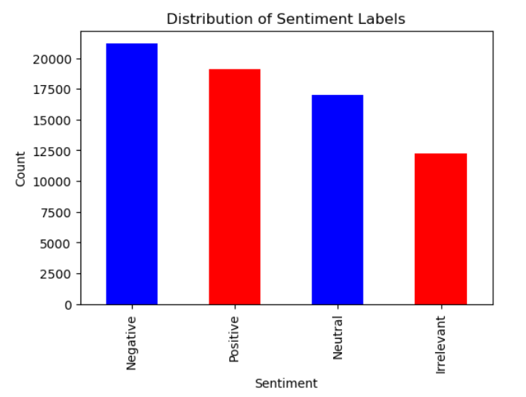

***Bar Plot for Top N Most Frequent words***

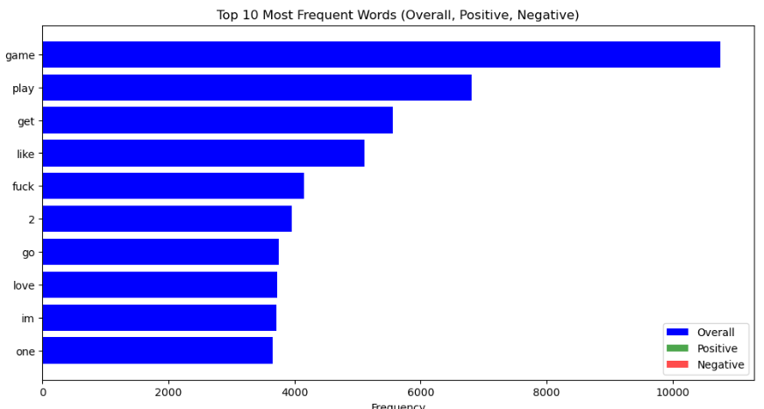

# 8. Prediction with New Data

In this section, we'll describe how the trained Naive Bayes classifier can be used to predict sentiment for new Twitter reviews. We'll also discuss the implementation of a user-friendly interface, which can be either a command-line interface (CLI) or a web application, where users can input their Twitter reviews for sentiment analysis.

***Using the Trained Model for Prediction***

After training the Naive Bayes classifier on the labeled Twitter dataset, we can use the model to predict the sentiment of new, unseen Twitter reviews. Here's how it can be done:

1. *Preprocessing*: Preprocess the new Twitter review in the same way as the training data. This includes tasks such as text cleaning, lowercase conversion, punctuation removal, stopwords handling, and stemming/lemmatization.

2. *Tokenization*: Tokenize the preprocessed review to obtain a list of tokens (individual words).

3. *Feature Extraction*: Transform the tokenized review into a numerical feature vector using the same feature extraction technique (e.g., BoW or TF-IDF) as used during training.

4. *Prediction*: Feed the feature vector into the trained Naive Bayes classifier to predict the sentiment (positive, negative, or neutral) of the new Twitter review.

***User-Friendly Interface***

To make the sentiment analysis accessible to users, you can create a user-friendly interface. Here are two common options:

Command-Line Interface (CLI):

- Users can interact with the sentiment analysis model through their terminal or command prompt.

- The CLI prompts users to input their Twitter reviews as text.

- The model processes the input, predicts the sentiment, and displays the result.

Code Snippet for CLI:

# Collect user input

user_input = input("Enter your Twitter review: ")

# Preprocess, tokenize, and extract features from user input

preprocessed_input = preprocess(user_input)

tokenized_input = tokenize(preprocessed_input)

feature_vector = extract_features(tokenized_input)

# Predict sentiment using the trained model

sentiment = nb_classifier.predict(feature_vector)

# Display the sentiment result to the user

print(f"Predicted Sentiment: {sentiment}")

# 9. Conclusion

In this concluding section, we'll summarize the project's objectives and achievements, discuss the importance of sentiment analysis in real-world applications, and mention any challenges faced during the project.

***Project Objectives and Achievements***

*Objectives:*

* The primary objective of this project was to perform sentiment analysis on Twitter data using natural language processing (NLP) and machine learning techniques.
* The project involved data cleaning, text preprocessing, tokenization, and the implementation of a Naive Bayes classifier for sentiment prediction.
* Additionally, the project aimed to create a user-friendly interface for predicting sentiment in new Twitter reviews.

*Achievements:*

* The project successfully accomplished the following:
* Obtained and prepared a Twitter dataset for analysis.
* Implemented data cleaning and text preprocessing techniques to standardize the text data.
* Utilized word-level tokenization to prepare the text for analysis.
* Implemented the Multinomial Naive Bayes classification algorithm for sentiment analysis.
* Evaluated the model's performance using metrics such as accuracy, precision, recall, and F1-score.
* Created a user-friendly interface for users to input Twitter reviews and receive sentiment predictions.

**Importance of Sentiment Analysis in Real-World Applications**

Sentiment analysis holds significant importance in various real-world applications:

1. Brand Monitoring: Companies and organizations use sentiment analysis to monitor public sentiment about their products or services. This information can help them make informed decisions about marketing strategies, product improvements, and customer satisfaction.

2. Social Media Monitoring: Social media platforms are rich sources of user-generated content. Sentiment analysis enables businesses to track public sentiment about their brand in real-time, identify emerging trends, and address customer concerns.

3. Customer Feedback Analysis: Sentiment analysis is used to analyze customer feedback, reviews, and surveys. It helps businesses understand customer satisfaction levels and areas that need improvement.

4. Market Research: Market researchers use sentiment analysis to gauge consumer opinions about products or trends. This data aids in market segmentation and targeting.

5. Political Analysis Sentiment analysis can be applied to political discourse to understand public sentiment about political candidates, policies, and events. It's valuable for election predictions and campaign strategies.

**Challenges Faced During the Project**

While working on the project, several challenges may have been encountered:

1. Data Quality: Real-world datasets often contain noise, missing values, or inconsistent labeling. Ensuring data quality through data cleaning and preprocessing can be time-consuming.

2. *Imbalanced Data*: Imbalanced datasets, where one sentiment class dominates, can lead to biased models. Techniques such as oversampling or undersampling may be needed to address this issue.

3. *Hyper parameter Tuning*: Choosing the right hyper parameters for the Naive Bayes classifier or other machine learning algorithms can be challenging and may require experimentation.

4. *User Interface Development*: Developing a user-friendly interface, whether a CLI or web application, requires additional skills in web development or user interface design.

5. *Interpreting Results*: Understanding the model's predictions and the impact of specific words or features on sentiment can be challenging, especially for complex models.

Despite these challenges, the successful completion of the project has provided valuable insights into sentiment analysis techniques and their practical applications in real-world scenarios.